Social Media: Guidelines for School Administrators
A lesson in doing the right thing for students and your staff.
By: Eamonn O'Donovan
District Administration, July/Aug 2012
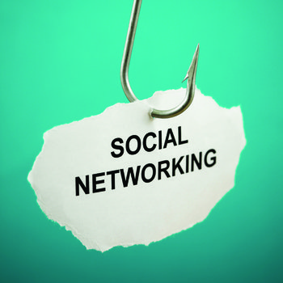
Social media tools like Facebook, Myspace, Instagram, Google+ and Flickr are potentially exciting learning and teaching tools that can help teachers and students make connections to ideas, skills and concepts in a 21st-century learning environment. However, social media are getting a bad rap in education. Some students use the tools in ways that pit their First Amendment rights against their responsibilities as students in brick-and-mortar schools.
In 2006, the American Civil Liberties Union filed suit against the Hermitage School District in Pennsylvania after the district suspended student Justin Layshock for creating an unflattering online parody of his principal. In 2007, a federal judge determined that the suspension was unconstitutional, and in 2010, a three-judge panel of the Third Circuit Court of Appeals ruled that the district violated the student’s First Amendment rights.
Clearly, schools must consider the rights of students to freedom of expression. Teachers mistakenly think they too have carte blanche First Amendment rights when it comes to their use of the Internet and social media. That is not the case. Teacher speech is more likely to be protected if it’s about matters of public interest, but there is a nexus between teachers’ private speech and their employment at school. Private speech should not unduly disrupt school activities.
Michael Simpson, NEA assistant general counsel who specializes in the First Amendment, writes in “Social Networking Nightmares: Cyberspeak No Evil,” “First, let’s debunk the free speech myth: Many teachers believe they have the absolute First Amendment right to post anything they want on social networking sites, including party pix and diatribes about the boss. After all, they’re on their own time and using their own resources.”
The courts have determined otherwise. Unfortunately, many teachers have been dismissed because of inappropriate posts or pictures on Myspace and Facebook. A high school English teacher was suspended for blogging about comments she wanted to make on student report cards. Some comments included “Nowhere near as good as her sibling. Are you sure they’re related?” and “Weirdest kid I’ve ever met.” Unfortunately for her, students and parents shared her blog on Facebook and Twitter, causing a stir that led to her suspension.
Probationary teachers can be dismissed without cause, and ill-conceived comments on social networks have ruined nascent careers. The landmark Pickering v. Board of Education case established that probationary teachers can be fired without violating their First Amendment rights even if they post typical silly comments about sex and booze that many young people post on Facebook.
Young teachers have grown up in the cyber age and often do not recognize the boundaries between work and play that their more mature peers observed. Boundaries are more easily violated with social networking technology. What was once private is now very public.

Protection from Predators
There are other boundaries that must not be crossed. Schools have a fundamental right to protect students from predators. When those predators are school staff who use texting and private conversations on sites like Facebook to bring vulnerable students into their confidence, school leaders must take action.
Schools need to provide training to their employees about social media for professional and private use. This is especially important for new employees who have grown up with social media and who work directly with students. Schools must devise a policy first to guide this training. While grounding practice in policy makes sense, however, developing a policy is fraught with potential obstacles.

Click Here to return to the Employee Training Page

