Updating Contact Information in iVisions

- Go to https://ivisions.gwd50.org and click “Login” and log in using your iVisions username and password.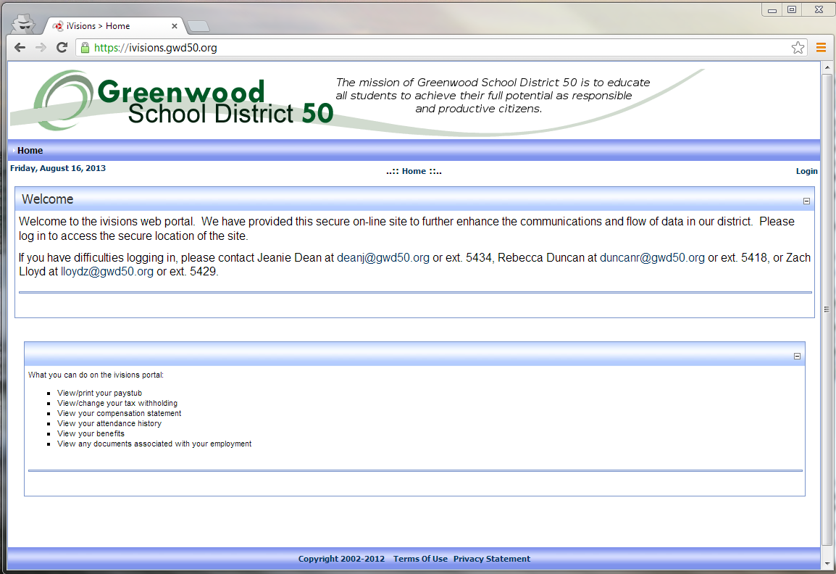

- Hover over “Employee Resources” -> “Profile” and click “Contact Information”. Update the information on this page with your correct contact information. Next, go back to “Employee Resources” -> “Profile” and click “Emergency Contacts.” Please update/enter the people we should contact on your behalf in the event of an emergency.
